REQUIREMENT ANALYSIS

DOCUMENT

BOOK SEARCH ENGINE

AUTHOR

NOORIN RAHILA

DATE

23/02/2023

TABLE OF CONTENTS

TABLE OF CONTENTS…………………………………………………2

INTRODUCTION

Purpose…………………………………………………………..….3

Overview…………………………………………………………….3

DESCRIPTION

Product Perspective…………………………………………………3

User Characteristics………………………………………………..4

Operating Environment…………………………………………….4

REQUIREMENTS

Functional Requirements………………………..…………………5

Performance Requirements……………..…………………………..5

Portability Requirements……………………………………………5

SYSTEM MODEL

Scenario……………………………………………………………..6

Use Case Model……………………………………………………..6

INTRODUCTION

Purpose
The goal of the project is to build full-featured web application to help the people easily search the books.

Overview
Book Search Engine Web based application is developed in the motive to provide easy search for e-books.The user is provided with search bar so that they can enter the book name. It view list of books with author name and published date.By clicking the needed book user can read the book in google books.

DESCRIPTION

Product Perspective
The product is independent and totally self-contained. It dependent only on Google API external framework.
System Interfaces
The system will use HTTP to retrieve book information from the Internet (such as google book.com); the user verifies the retrieved information and enters additional information to read the books.
User Interfaces
The application provide an easy-to-use user interface using Javascript library and framework.

Communication Interfaces
Communication interfaces between this system and remote Internet servers will be implemented with Hypertext Transfer Protocol (HTTP) .

User Characteristics
User of the application should be able to retrieve book information from the entered name and select the book they want to read. The user can do the following functions with this web application:

                - Search
                - Select
                - Read in Google Books

Operating Environment
Operating Environment for the book search engine web application is as listed below
                - Distributed database
                - Client/server system
                - Operating system: Windows , Mac OS , Android
                - Platform: React js

REQUIREMENTS
The web application shall have following features:
            - Be able to store and manage user content assets.
            - It should provide real-time reports and dashboards.
            - It need to be easy access to all users.

Functional Requirements
Validity checks should be done on all the inputs. In case of abnormal situations, such as invalid input or overflow, the system should exit gracefully after giving the user an informative message box. Crashes should be avoided.

Performance Requirements
The system should run adequately fast on any type of UI i.e Computer , iPad , mobile phone and laptop.

Portability Requirements
The web application runs on all type of operating system Windows , Mac OS , android . The web application is responsive on all dimensions.

SYSTEM MODEL

Scenario

User A uses book search engine application. Consider the user doesn’t have any knowledge of programming language . User A intends in search of book to read. User A performs following function which is illustrated in Use case diagram.

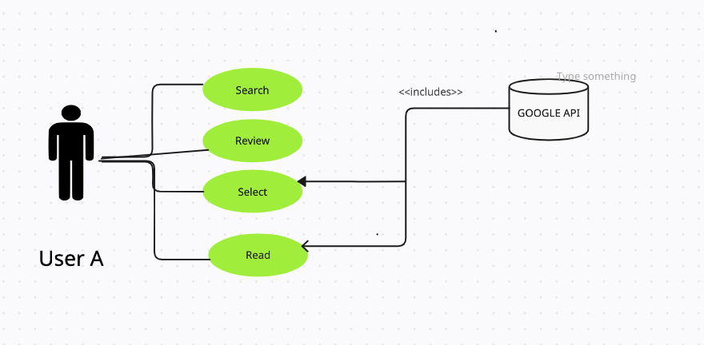
Use Case Model

